**PASSWORD PROGRAM: PROJECT REPORT**

Kyle Christie

[B00415210]

Written 11/04/2022

Finalised --/--/--

Lecturer: Joanna Olszewska

Algorithms & Collections



# Overview

The aim of my project was to provide computer users with a secure, reliable and simple password manager program that also allows users to find out whether their data has been breached. The core principles behind this software was to improve login security and awareness of data security while making an accessible and free product. I have since implemented and tested a software solution based on the previous design brief.

**Table of Contents**

​ Overview 2

​ 1. Development Lifecycle 3

​ 2. Requirements 7

​ 3. Approach 10

​ 3.1. Data Structure 10

​ 3.2. Algorithms 10

​ 3.3. Complexity Analysis 10

​ 3.4. Testing and Metrics 10

​ 4. Results 11

​ 4.1. Verification & Validation 11

​ 4.2. Reflecting on Methods 11

​ 4.3. SWOT Analysis 11

​ 4.4. Ethics and Legalities 11

​ References 11

Table of Figures

Figure 1: An overview of my Trello boards (17/4/22) 3

Figure 2: Trello: Analysis & Design Board (24/1/2022) 4

Figure 3: Trello: Analysis & Design Board (17/4/2022) 5

Figure 4: Trello: Dev Cycle/Protyping Board (9/3/2022) 5

Figure 5: Trello: Dev Cycle/Protoyping Board (17/4/2022) 6

Figure 6: Initial MOSCOW analysis for Password Program 7

Figure 7: Initial class diagram 8

Figure 8: Finalised class diagram 9

# 1. Development Lifecycle

Throughout the development of my project, I utilised the ‘Rapid Application Development’ methodology. The reasoning behind this being practicality as well as facilitating a linear process in which I don’t waste time revisiting previous steps. I could also focus on a prototype which I quickly develop, test and then finalise. I kept track of my progress via Trello creating 4 boards which represent each stage of RAD.

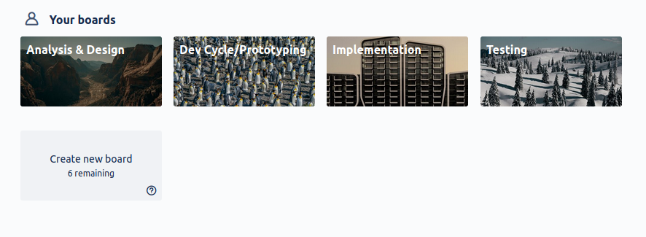Figure 1: An overview of my Trello boards (17/4/22)

While not in order, each stage is represented. Within each board, I utilised my own Kanban style of task/issue tracking with a to-do list, in-progress list and complete list for tasks. In certain boards, I might track specific issues or write notes that might be useful as can be seen in my prototyping board which I have a specific list of ‘Known bugs’ with a coloured category representing current status or severity.

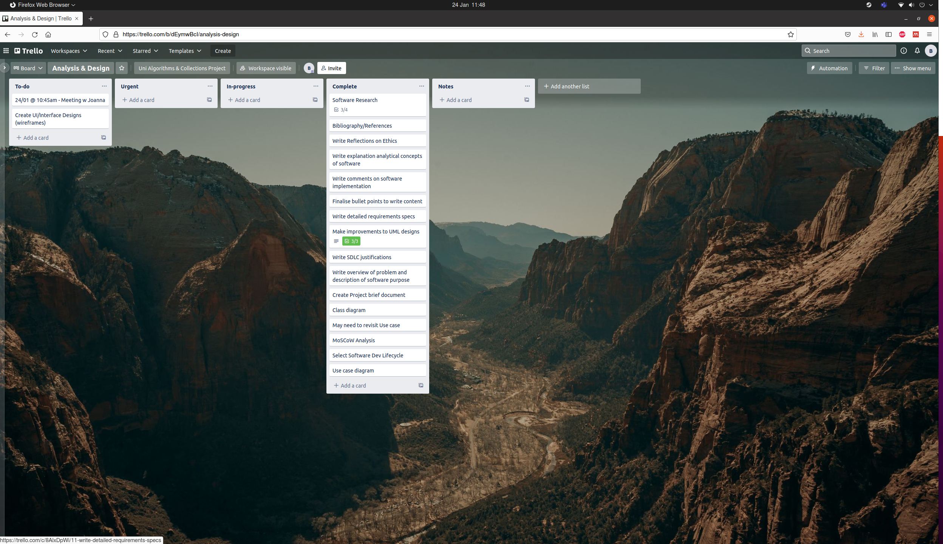Figure 2: Trello: Analysis & Design Board (24/1/2022)

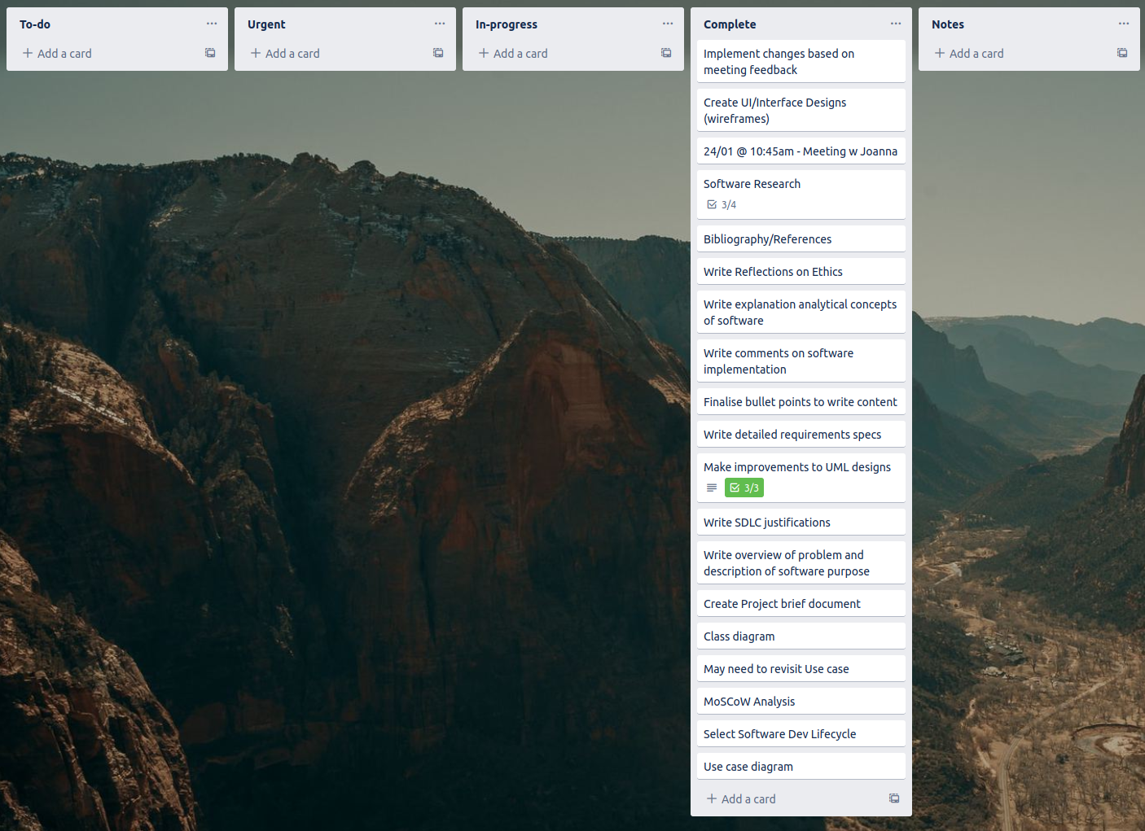Figure 3: Trello: Analysis & Design Board (17/4/2022)

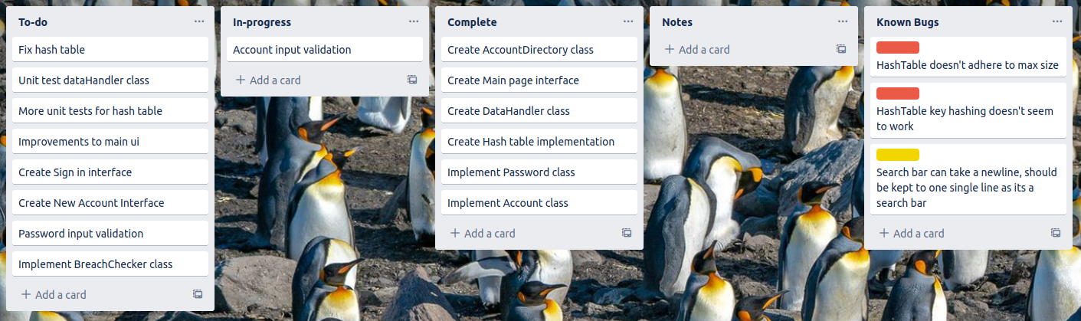Figure 4: Trello: Dev Cycle/Protyping Board (9/3/2022)

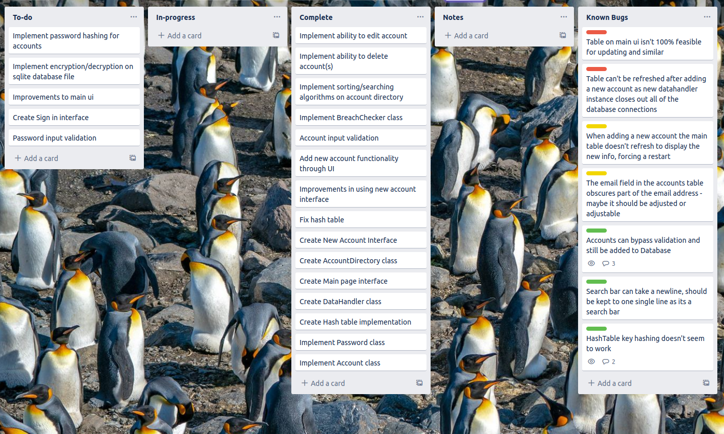Figure 5: Trello: Dev Cycle/Protoyping Board (17/4/2022)

# 2. Requirements

After figuring out my base requirements, I carried out MOSCOW analysis to categorise each requirement into what is most and least necessary.

After several more designs, I developed class diagrams denoting the final requirements.

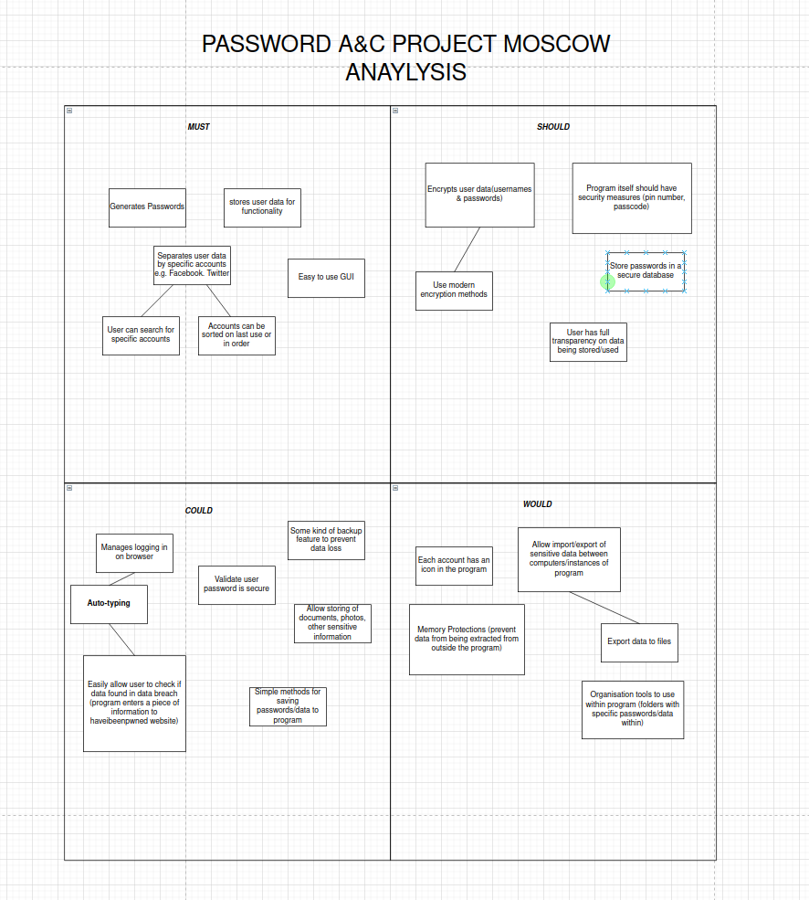Figure 6: Initial MOSCOW analysis for Password Program

After several meetings with the client, I built on top of this class diagram to create the final design which would then be used throughout development – this would not be able to change due to my use of the RAD methodology.

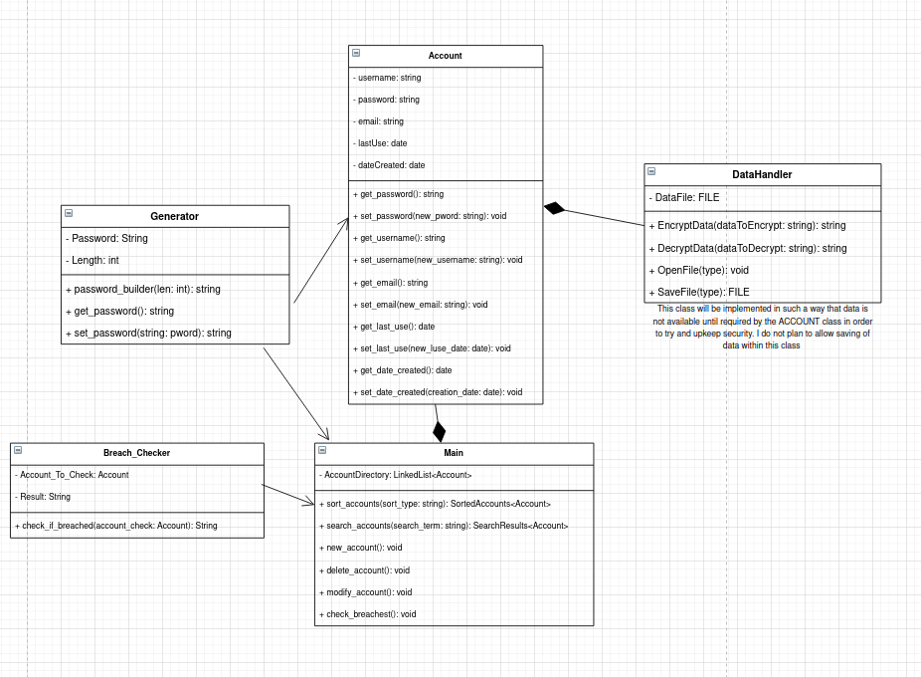Figure 7: Initial class diagram

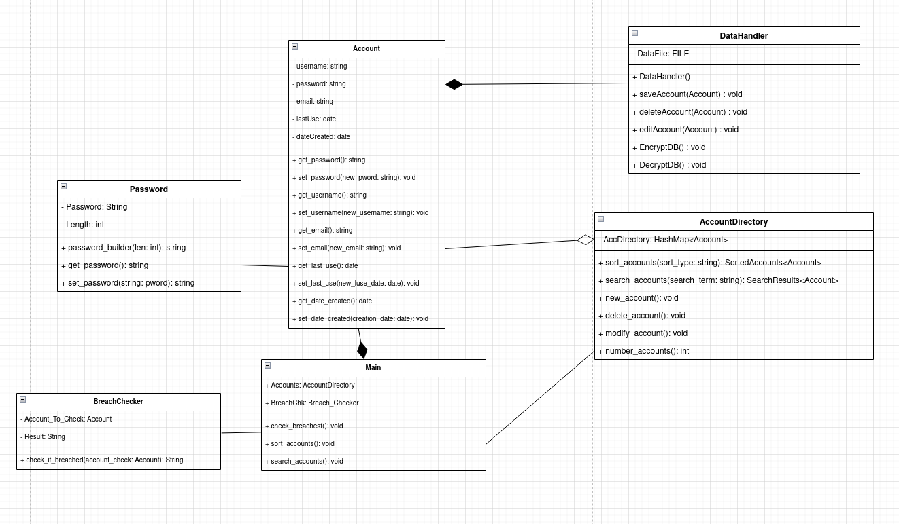Figure 8: Finalised class diagram

In the final design, several classes are present which are necessary for the application to function. Account can be thought of as the core of the program as it allows data to be accessed and stored from a database, meeting the *strict* requirements of storing data and separating data. Password is a small component of Account and allows for the generation of secure passwords, allowing the user to better secure their accounts – another necessary requirement. AccountDirectory is built on a HashTable which allows for the storing and manipulation of specific Accounts, this was a necessary addition to efficiently manage and organise several user accounts. DataHandler allows for interaction with account storage which, in the final implementation, is an SQLite database. Finally, the class BreachChecker permits the user to check if their data was recently involved in a major data breach. This is facilitated by the use of the website ‘haveibeenpwned’ which tracks data breaches and alerts users when/if their data is present.

# 3. Approach

During my prototyping stage, I utilised C++ and the Qt IDE. The initial reasoning was a want to gain experience in developing C++ software as well as cross-platform functionality. The program was developed on an Ubuntu Linux Workstation however the use of Qt will allow me to produce versions compatible with Windows and/or MacOS. I used various standard Qt libraries such as QString, QDate, QException, QDebug and QFile. While the program mostly consists of Qt C++ there is also a small amount of standard C++ spread throughout the code. As I previously discussed, I used an SQLite database in order to store user data. I planned to use the Qt Cryptographic Architecture in order to hash passwords and encrypt files but could not do so due to time constraints.

During development I utilised a standard object-oriented approach. Implementing classes as they are represented in the finalised design *[fig. 8].* Specifically, when implementing my Hash table, I utilised a template class which allows me to use almost any value for my table key or stored data, these are commonly known as generic types. There are a handful of instances where I had to use overloading to create several different versions of a single function or attribute.

## 3.1. Data Structure

As previously mentioned, this program makes use of a Hash Table. This is used in the AccountDirectory class in order to store many user accounts. It was chosen for its speed as you can locate data by simply providing the key value. In this implementation, key clashes are solved by placing data in the next available space rather than chaining data together, this is known as Open Addressing. The key itself is generated via;

(*the day of account creation* + *the month of creation*) MOD *initial table size*

With 50 being the initial set size of the Hash table. These values were selected as none other would successfully create keys. I decided to utilise Open Addressing as it was a simpler solution and I felt that chaining account data together would needlessly complicate the AccountDirectory class and its underlying functionality.

## 3.2. Algorithms

## 3.3. Complexity Analysis

## 3.4. Testing and Metrics

# 4. Results

## 4.1. Verification & Validation

## 4.2. Reflecting on Methods

## 4.3. SWOT Analysis

## 4.4. Ethics and Legalities

# References